How To: Create a Hello Word application using Prism

This article describes how to create and display a view in a module using [Prism](http://www.codeplex.com/prism). To create your first Hello World application, perform the procedures in this section:

# Steps

This article includes the following tasks:

* Create the initial solution
  + PrismSample project
* Add the HelloWord module
  + HelloWordView view
  + HelloWordModule class
* Check the results

# Create the initial solution

1. In **Visual Studio**, point to **New** on the File menu, and then click **Project**.
2. In the **New Project** dialog box, expand **Visual C#** projects, and then select **Windows**.
3. Select the **WPF Application** Visual Studio template.
4. In the **Name** and **Solution Name** boxes, type *PrismSample* and *HelloWord* respectively.
5. Click **OK**.

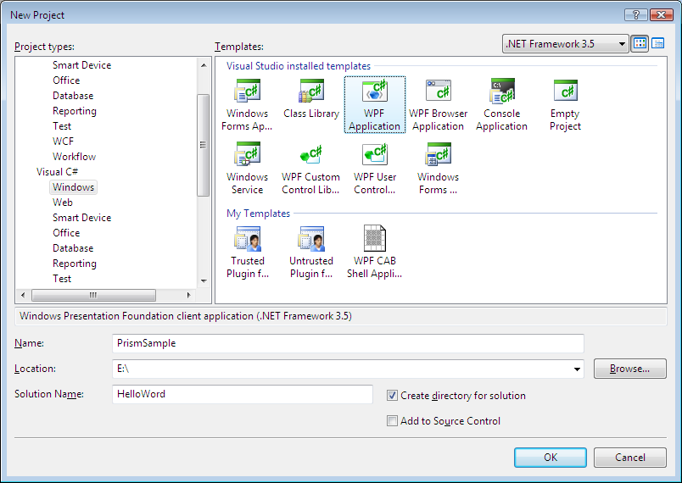

**Figure 1**

*New Project dialog box*

1. Add the **_Prism Framework** and **Modules** solution folders.
2. Add the following Prism projects to the **_Prism Framework** solution folder.

* Prism.csproj
* Prism.Interfaces.csproj

You can get the latest source code of Prism projects from [here](http://www.codeplex.com/prism/SourceControl/ListDownloadableCommits.aspx).

The structure of your initial solution should looks like the one in the Figure 2.

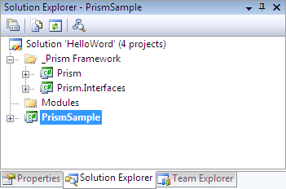

**Figure 2**

*Initial solution structure for a Prism application*

## PrismSample project

1. Add references to:

* **Prism** project
* **Prism.Interfaces** project

1. Rename the **Windows1.xaml** file to **Shell.xaml**
2. Open the **Shell.xaml.cs** and rename the *Window1* class to *Shell*. Press **Shift+Alt+F10** to rename “*Window1*” to “*Shell*” in the whole solution.
3. Open the **Shell.xaml** file and replace the XAML code for the following one:
   * 1. C#
     2. <Window x:Class="PrismSample.Shell"
     3. xmlns="http://schemas.microsoft.com/winfx/2006/xaml/presentation"
     4. xmlns:x="http://schemas.microsoft.com/winfx/2006/xaml"
     5. xmlns:prism="http://www.codeplex.com/prism"
     6. Title="Prism Hello World" Width="400" Height="300">
     7. <ItemsControl prism:RegionManager.RegionName="MainRegion"/>
     8. </Window>
4. Add a new class to the project named **Bootstrapper**. Add the following using statements before the class signature:
   * 1. C#
     2. using System.Windows.Controls;
     3. using Prism.Interfaces;
     4. using Prism.Regions;
     5. using HelloWorld;
5. Replace the definition of the **Bootstrapper** class for the following one:
   * 1. C#
     2. internal class Bootstrapper
     3. {
     4. public void Initialize()
     5. {
     6. RegionAdapterMappings mappings = new RegionAdapterMappings();
     7. mappings.RegisterMapping(typeof(ItemsControl), new ItemsControlRegionAdapter());
     8. Shell shell = new Shell();
     9. IRegionManager rms = new RegionManager(mappings);
     10. RegionManager.SetRegionManager(shell, rms);
     11. shell.Show();
     12. IModule helloWorldModule = new HelloWorldModule(rms);
     13. helloWorldModule.Initialize();
     14. }
     15. }
6. Open the **App.xaml** and delete the following property inside the **Application** tag:
   * 1. C#
     2. StartupUri="Window1.xaml"
7. Open the file **App.xaml.cs** file and add the following constructor for the **App** class:
   * 1. C#
     2. public App()
     3. {
     4. Bootstrapper bootStrapper = new Bootstrapper();
     5. bootStrapper.Initialize();
     6. }

# Add the HelloWord module

1. Add a new **Class Library** project to the Modules solution folder called **HelloWord**. To do this, right-click in the Modules solution folder, point to **Add** and then select **New Project**.
2. In the **Add New Project** dialog box, click in **Class Library** Visual Studio template and type *PrismSample* in the **Name** box.
3. Click **OK**.
4. Add references to:

* **Prism** project
* **Prism.Interfaces** project

1. Create the **Views** folder inside the project.

## HelloWordView view

1. Add a new user control (WPF) to the **Views** folder named **HelloWordView**.
2. Open the **HelloWordView.xaml** file and replace the XAML code for the following one:
   * 1. XAML
     2. <UserControl x:Class="HelloWorld.Views.HelloWorldView"
     3. xmlns="http://schemas.microsoft.com/winfx/2006/xaml/presentation"
     4. xmlns:x="http://schemas.microsoft.com/winfx/2006/xaml">
     5. <Grid x:Name="GeneralGrid">
     6. <TextBlock Text="Prism Hello World" Foreground="Green" HorizontalAlignment="Center" VerticalAlignment="Center" FontFamily="Calibri" FontSize="24" FontWeight="Bold"></TextBlock>
     7. </Grid>
     8. </UserControl>

## HelloWordModule class

1. Rename the **Class1.cs** file inside the **HelloWord** project to **HelloWordModule.cs**. Click **Yes** in the dialog box that appears when you rename the file.
2. Add the following using statements before the class signature:
   * 1. C#
     2. using HelloWorld.Views;
     3. using Prism.Interfaces;
3. Replace the code inside the **HelloWordModule** class for the following one:
   * 1. C#
     2. public class HelloWorldModule : IModule
     3. {
     4. private readonly IRegionManager regionManager;
     5. public HelloWorldModule(IRegionManager regionManager)
     6. {
     7. this.regionManager = regionManager;
     8. }
     9. public void Initialize()
     10. {
     11. IRegion mainRegion = this.regionManager.GetRegion("MainRegion");
     12. mainRegion.Add(new HelloWorldView());
     13. }
     14. }
4. Add a project reference in the **PrismSample** project to the **HelloWord** project.

# Check the results

1. Set the **PrismSample** project as **Startup** project. To do this, right-click in the **PrismSample** project and then select **Set as Startup Project**.
2. Press **F5** to compile and run the application.
3. You should see the following window:

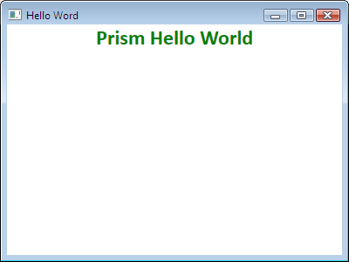

**Figure 3**

*Application running*

1. Close the application.